**CLOUD COMPUTING CIA - 1**

NAME : GIDIYON S

ROLL NO : 727721EUIT039

QUESTION NO 3:

1.The name of the IAM user should be “EC2admin1” :

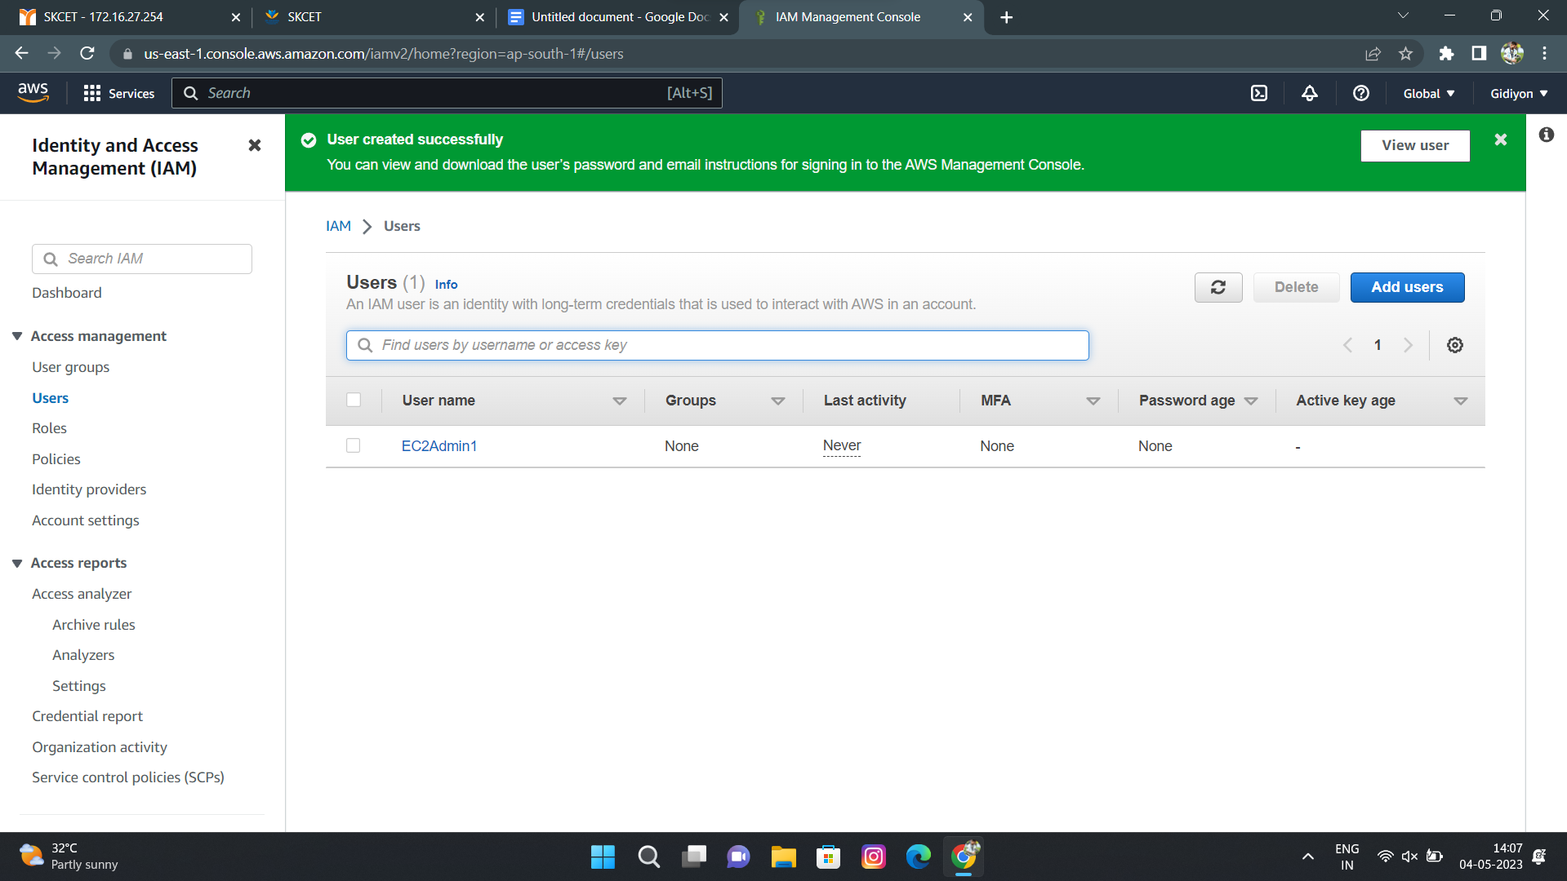

2.The name of the IAM group should be “EC2-Admins” :

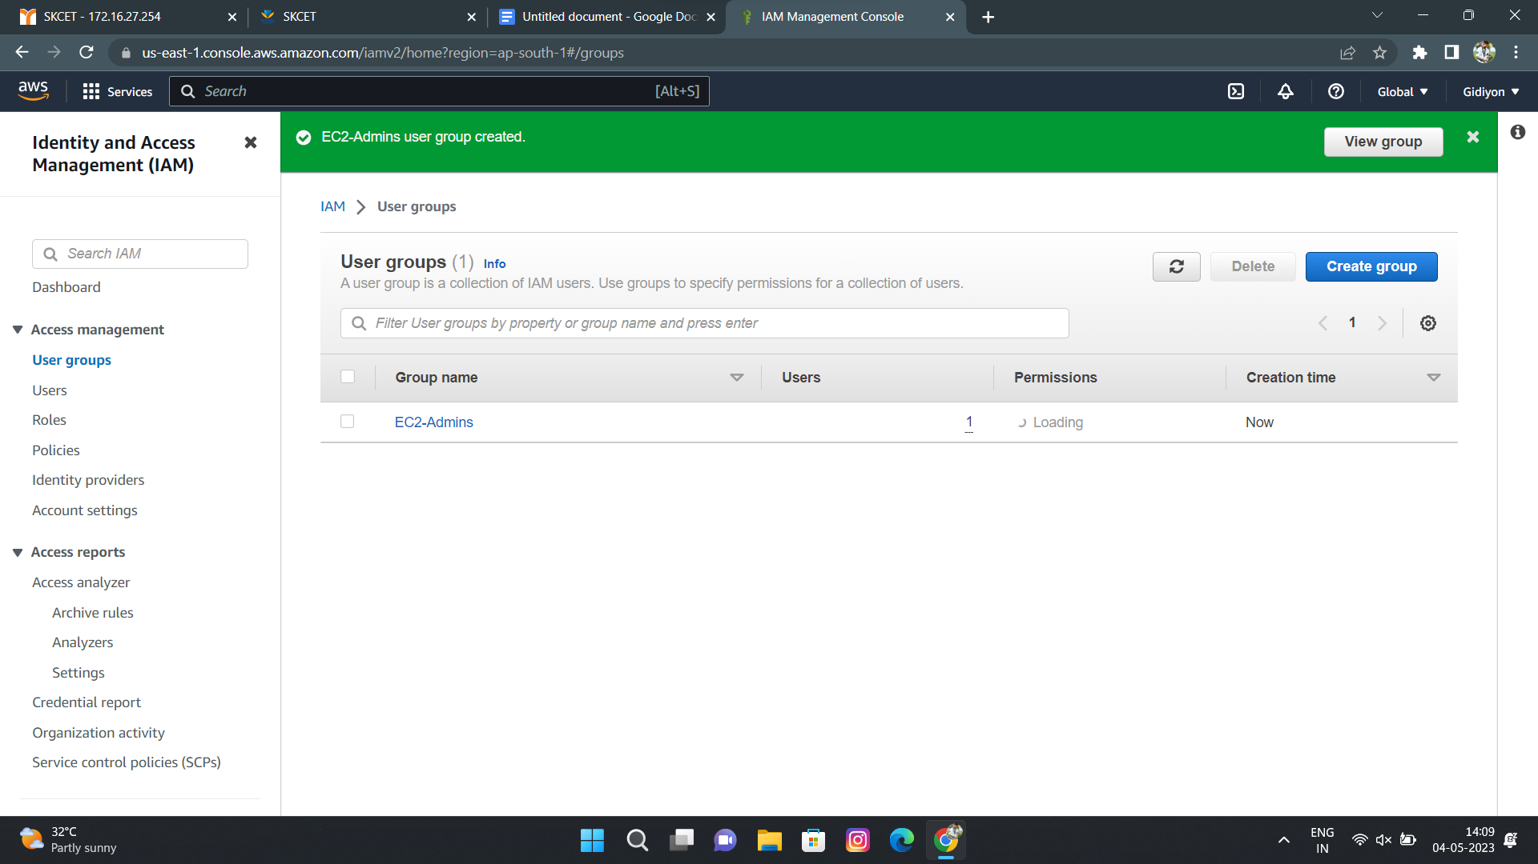

3.The “AmazonEC2FullAccess” policy should be attached :

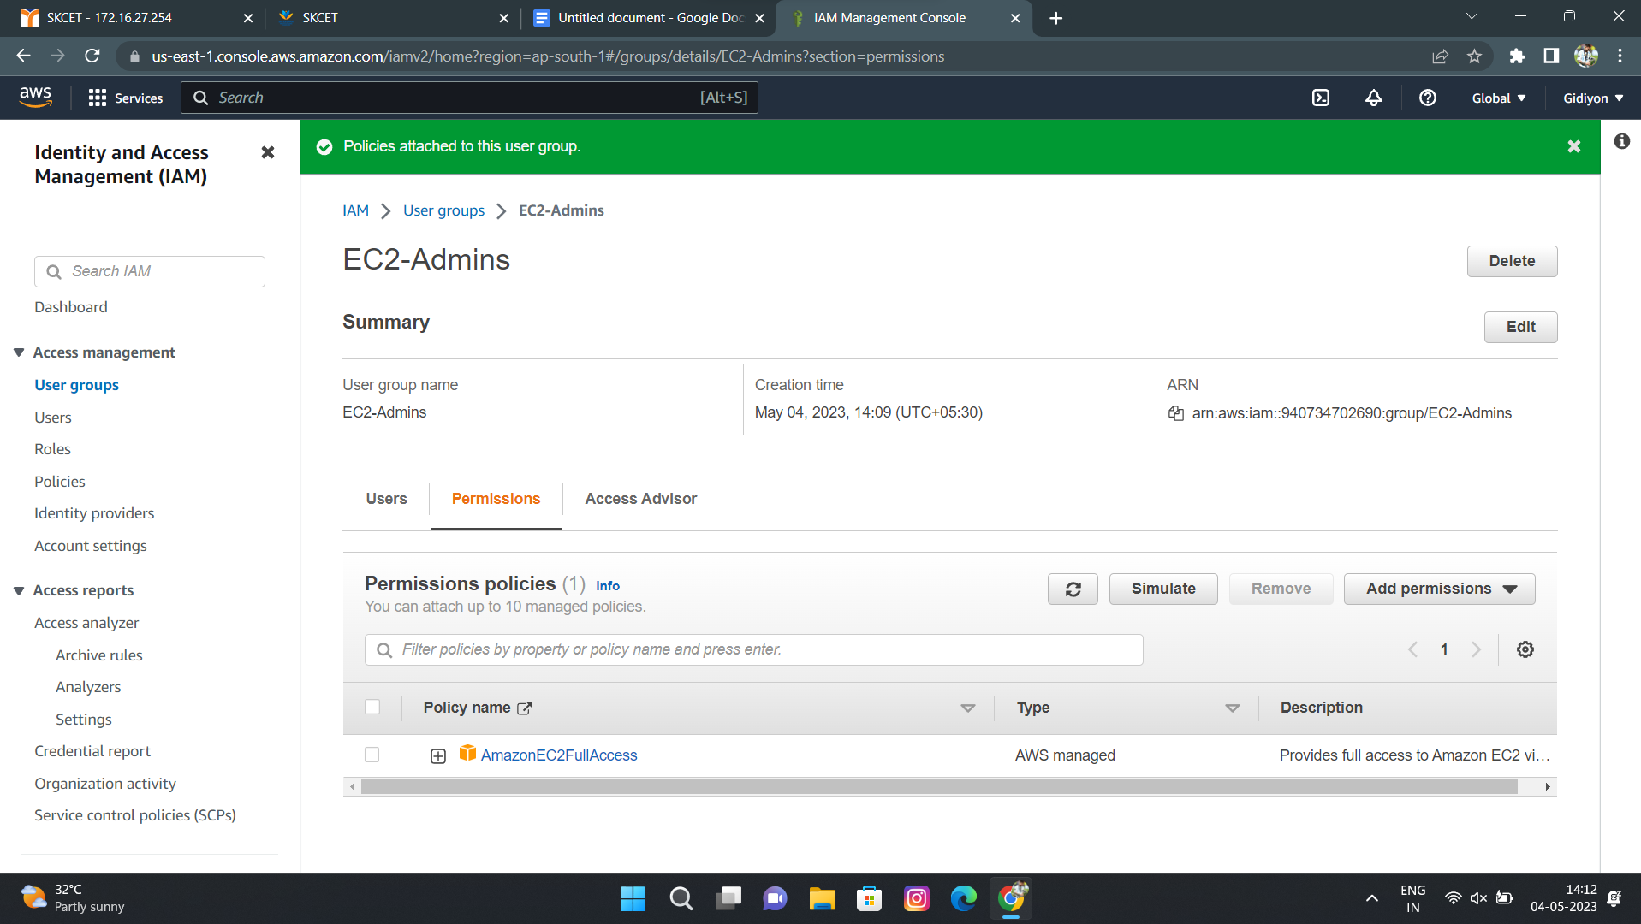

4. The “AutoScalingFullAccess” policy should be attached :

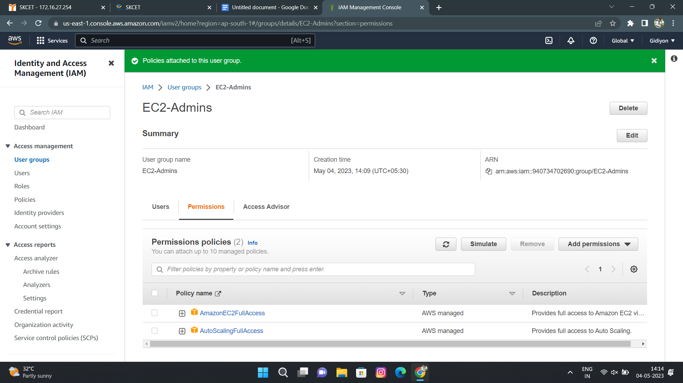

QUESTION NO 1:

1.Give the name of both server & keypair as “ec2usecase2” :

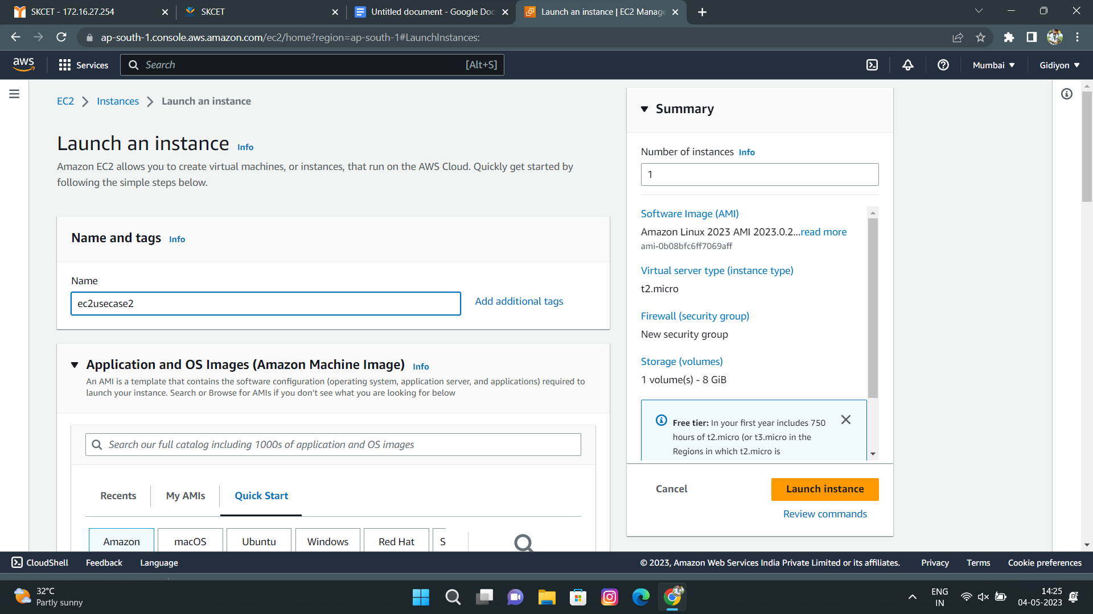

INSTANCE :

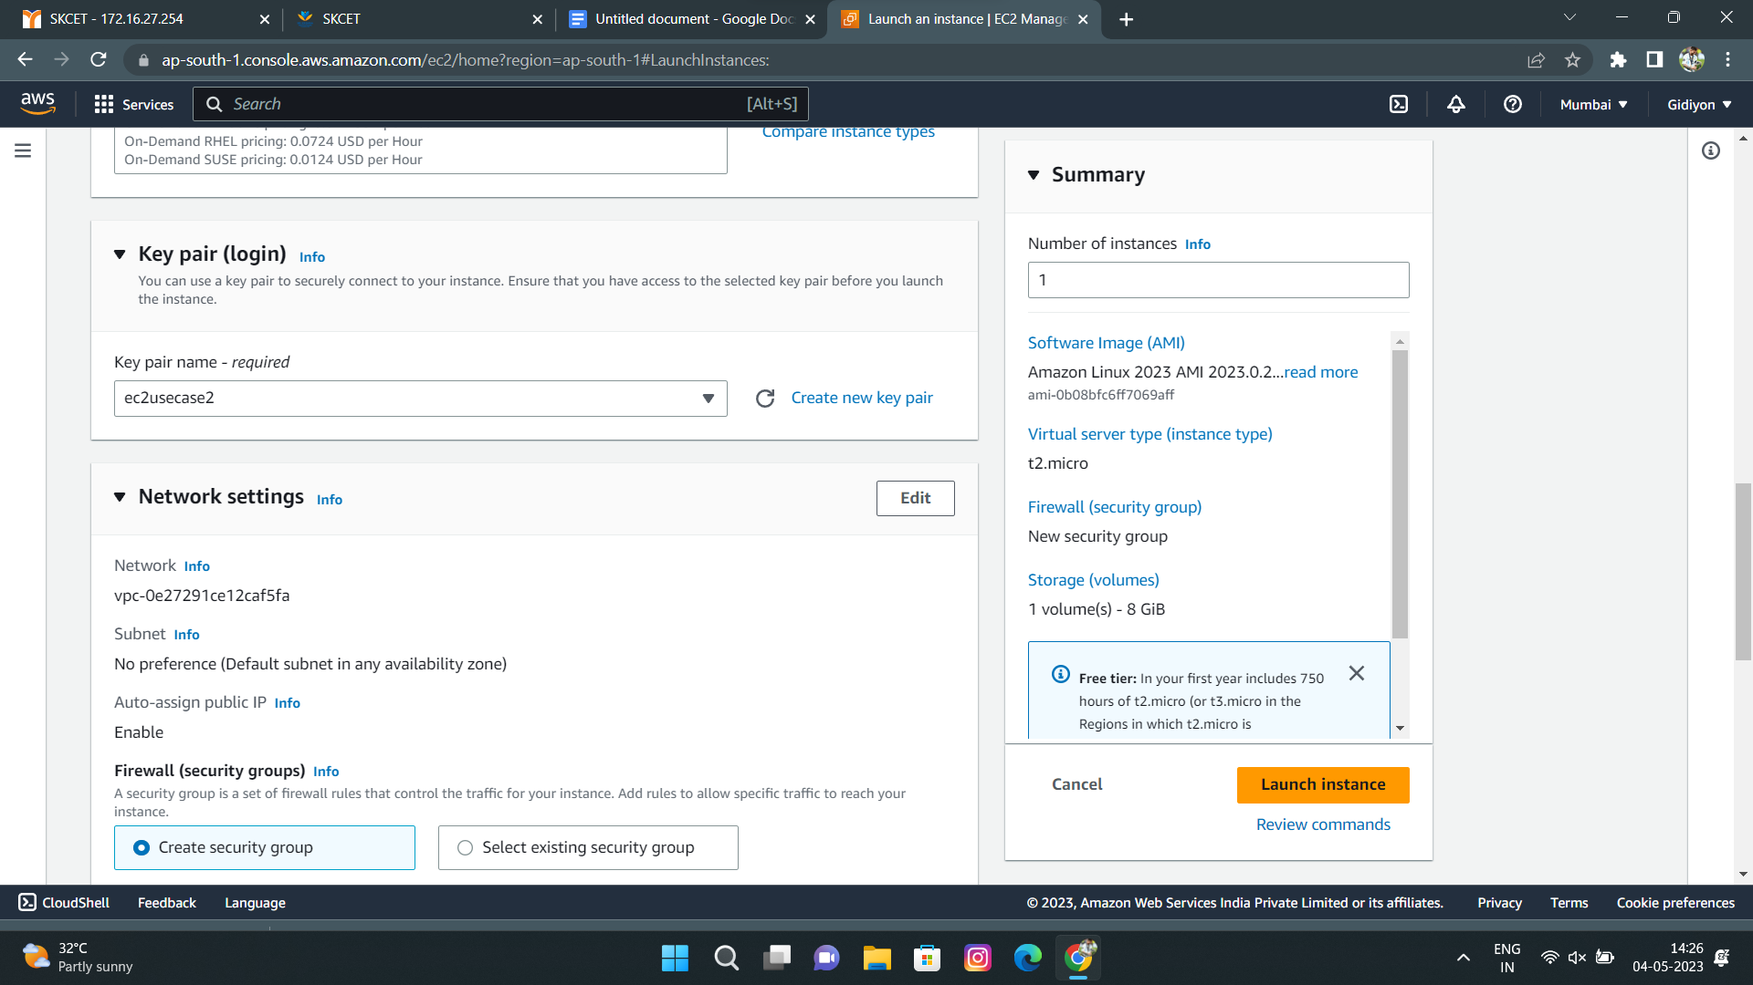

2. Increase the root EBS volume size to 10 GB from default :

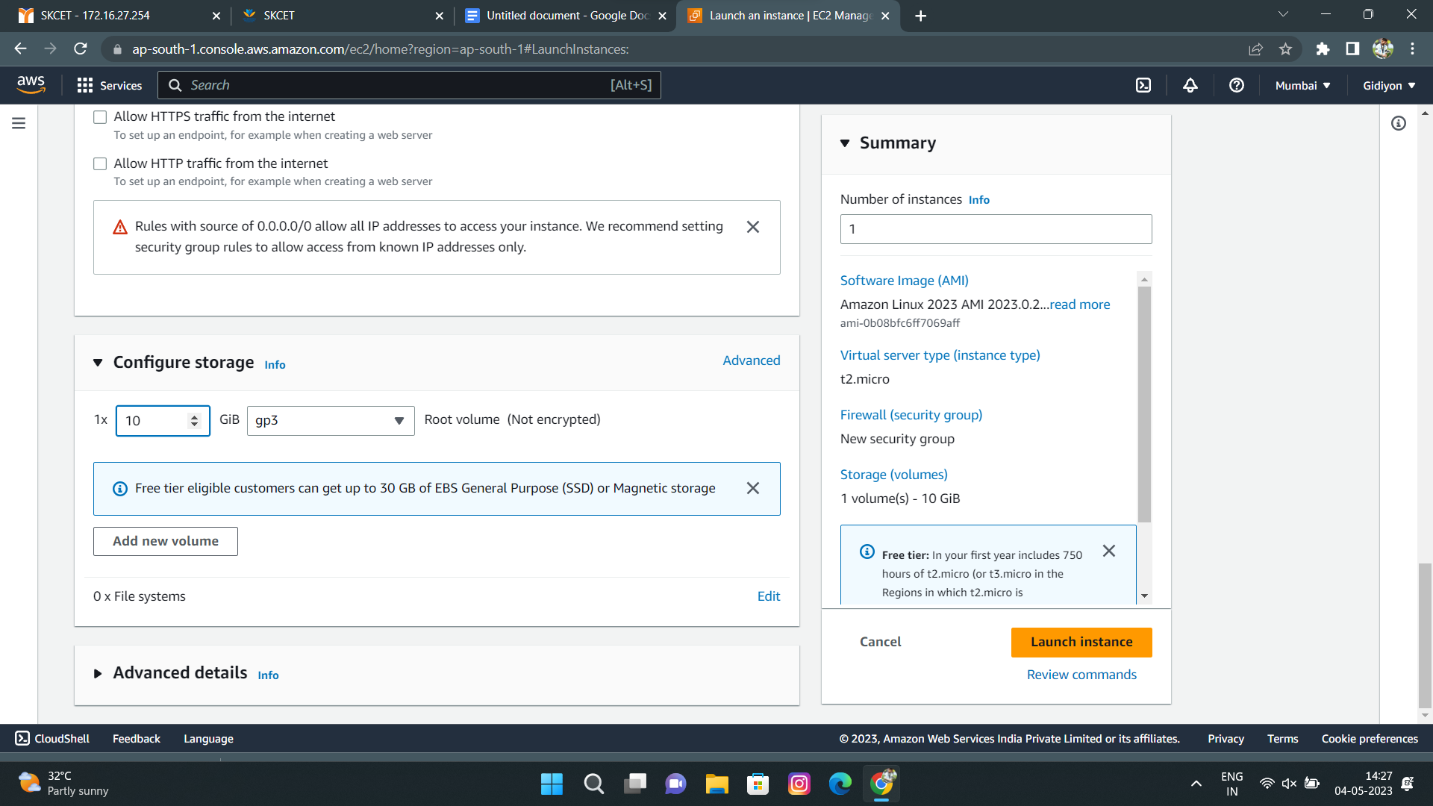

3. Expose Port No : 22 for taking Putty Remote Connection :

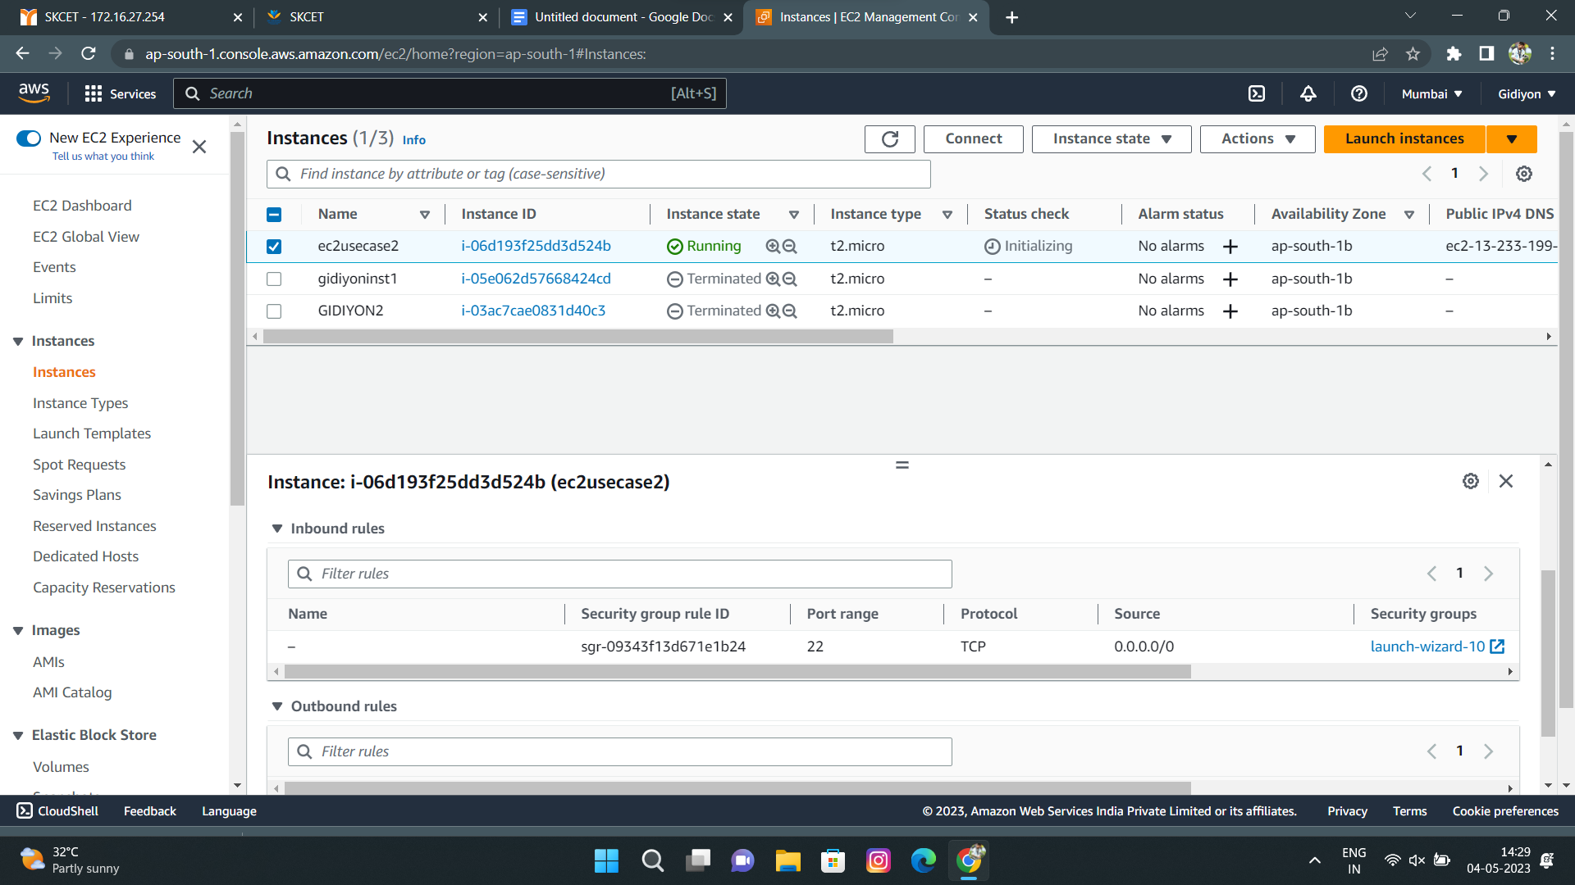

4. Select the AMI from Amazon Linux Platform :

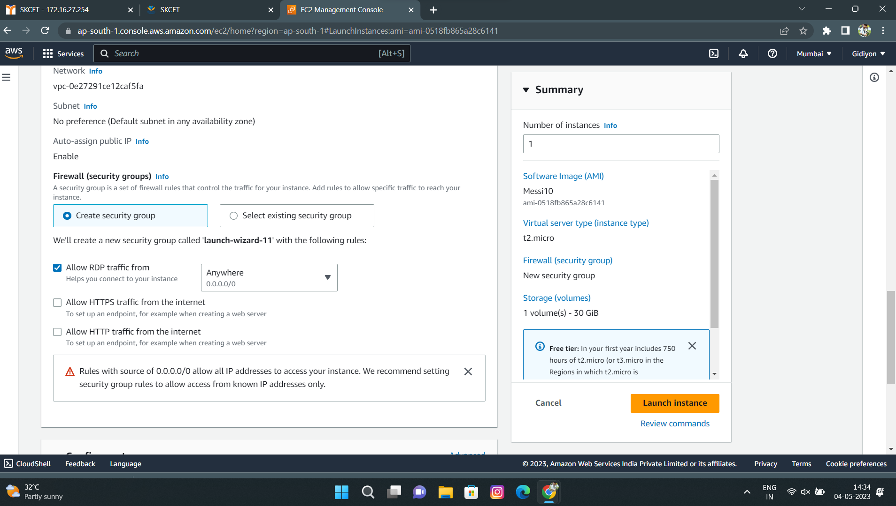

QUESTION NO 2 :

1.Give the name tag of both server and keypair as “ec2usecase1” :

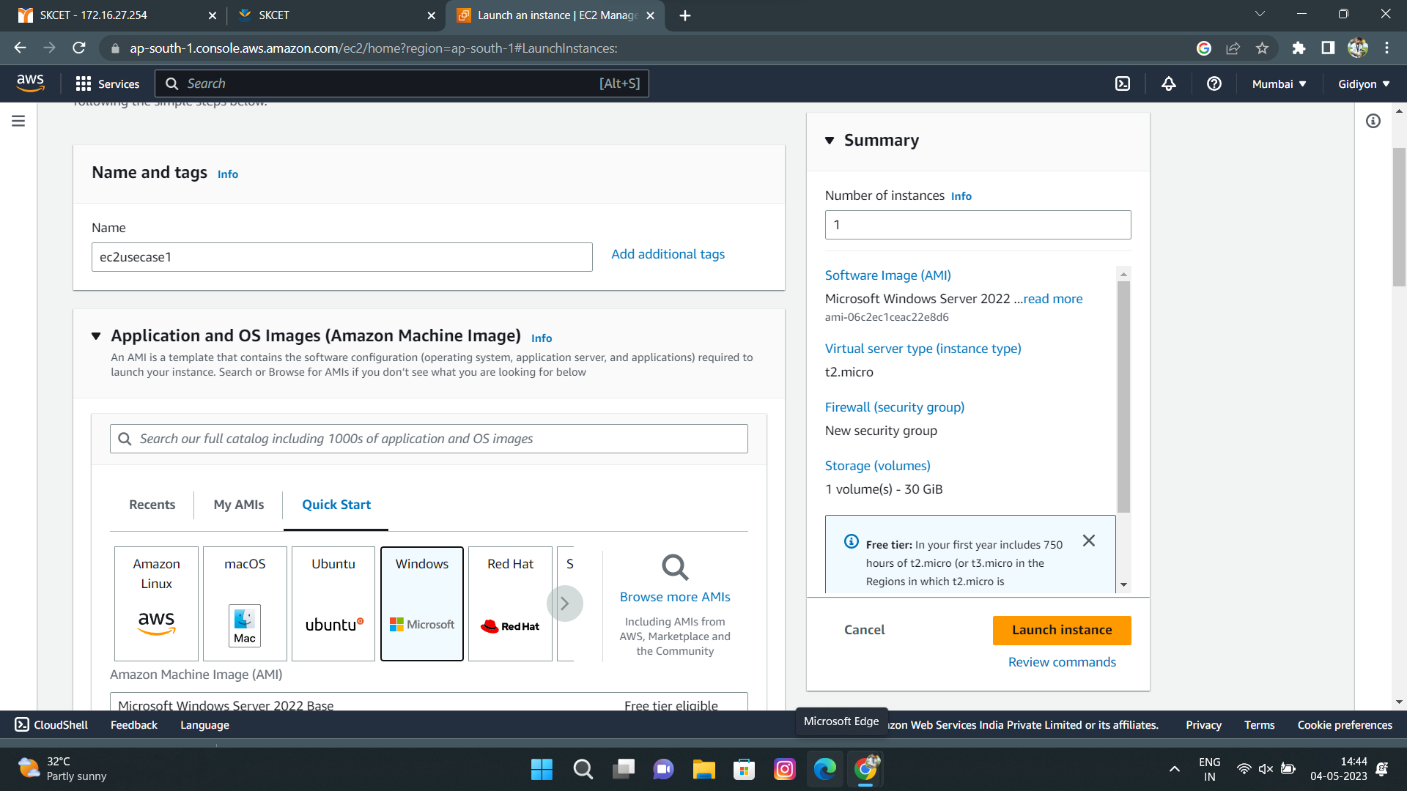

2. Select the AMI from the windows OS platform :



3. Ensure that Auto Assigned Public IP must be enabled :

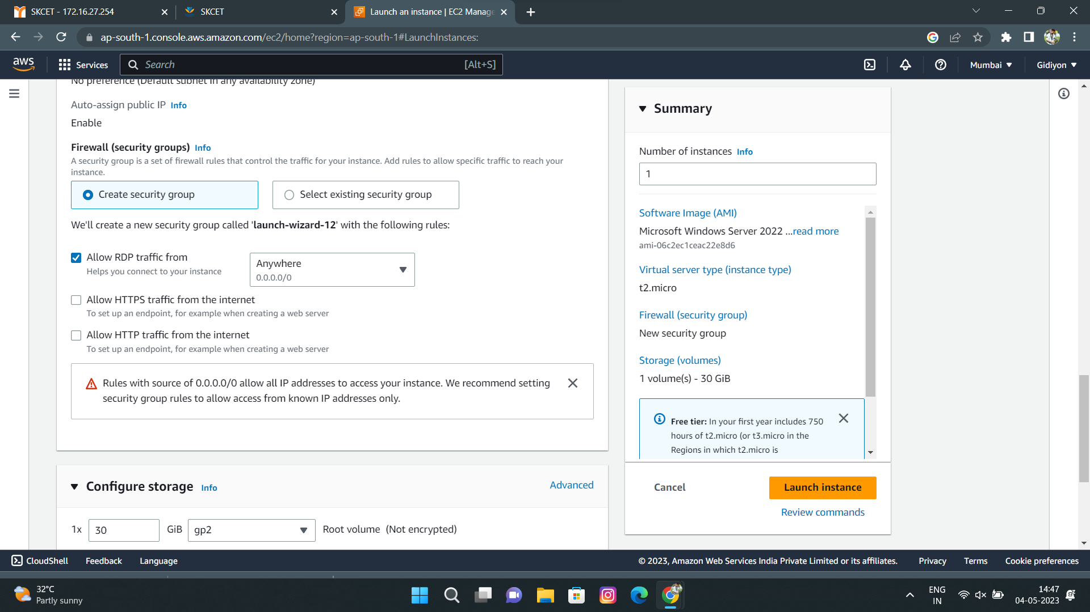

4.Expose port NO. 3389 for taking the remote desktop connection :

